**Manali Tourism**

This website is a single page application, made for the tourist who want to have knowledge and guidance while visiting Manali. The website has been made with love for the users. It is built using HTML, CSS, Bootstrap and JavaScript. Given below are the screenshots for the same.

1. Navigation Bar – this is the navigation bar with each of the link references redirecting to the specific section and logo redirecting to the start of the page.

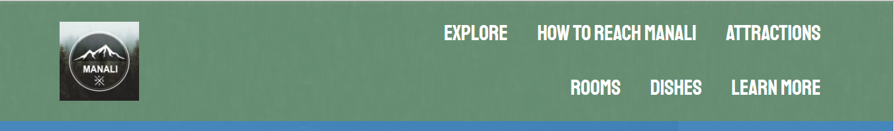

1. About – This page has the basic information about manali, along with 4 images which are given a timer of 3 sec to animate or change

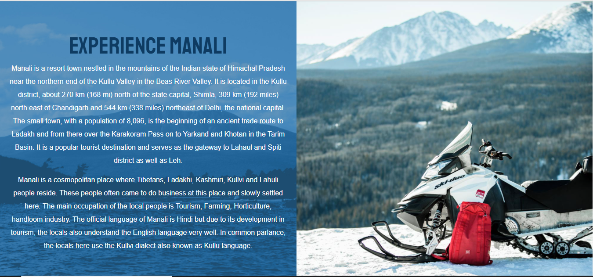

1. Explore – This section has information about different activities than can be done in Manali with respective to the seasons, i.e. Summer and winter. Each of the links directs to the specific activity page.

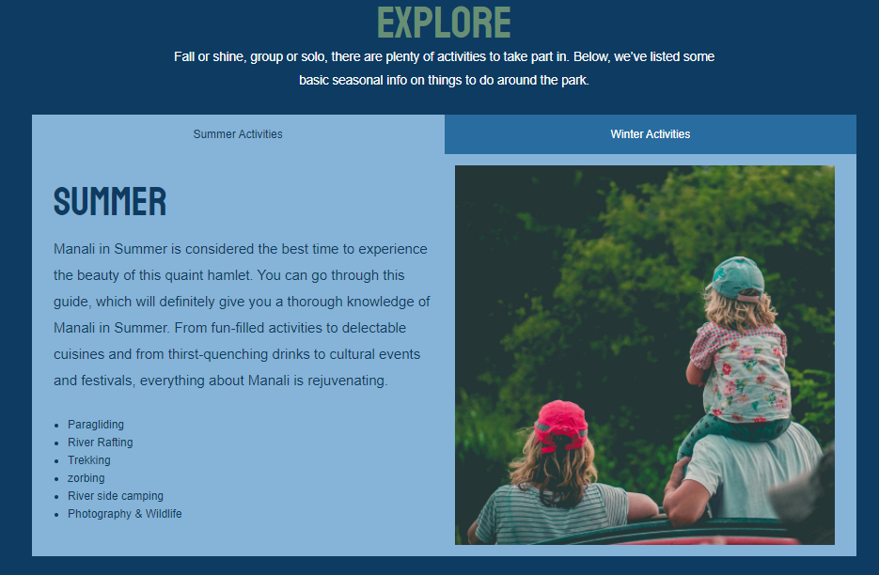

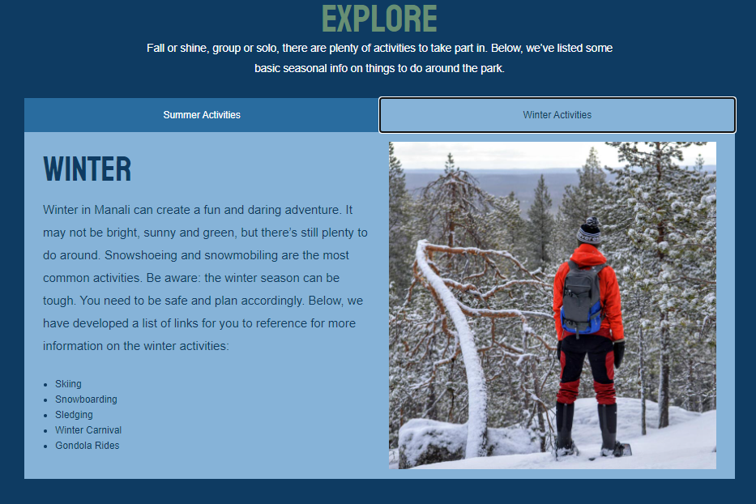

1. Major Attractions – This section of the website has the information about the different places and their information. All the places are put as a carousal with a timer of 3 sec to change themselves.

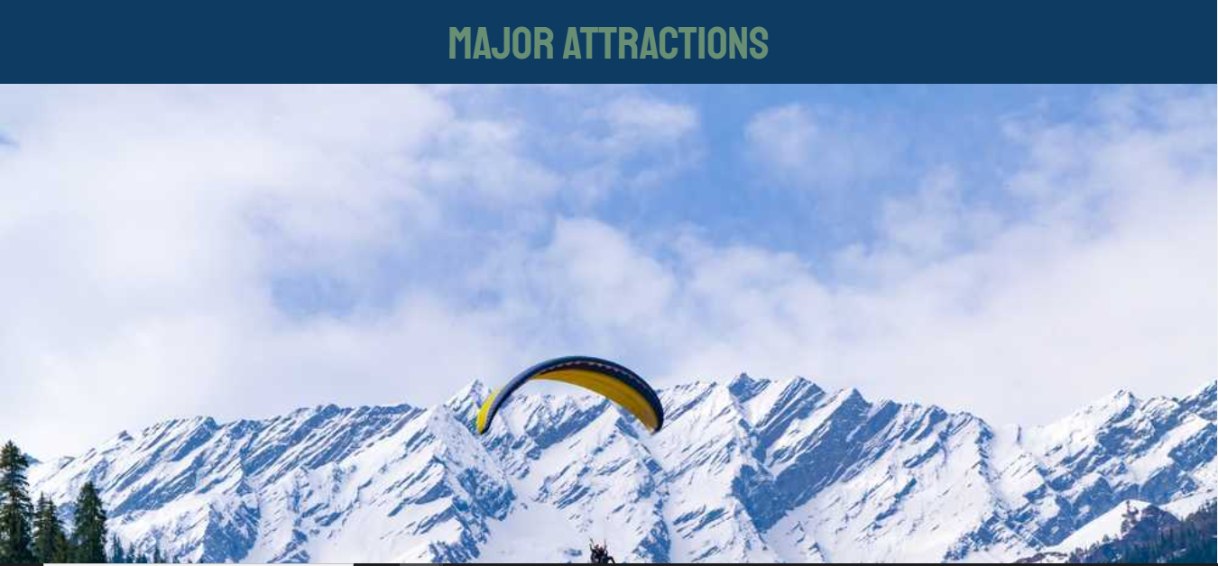

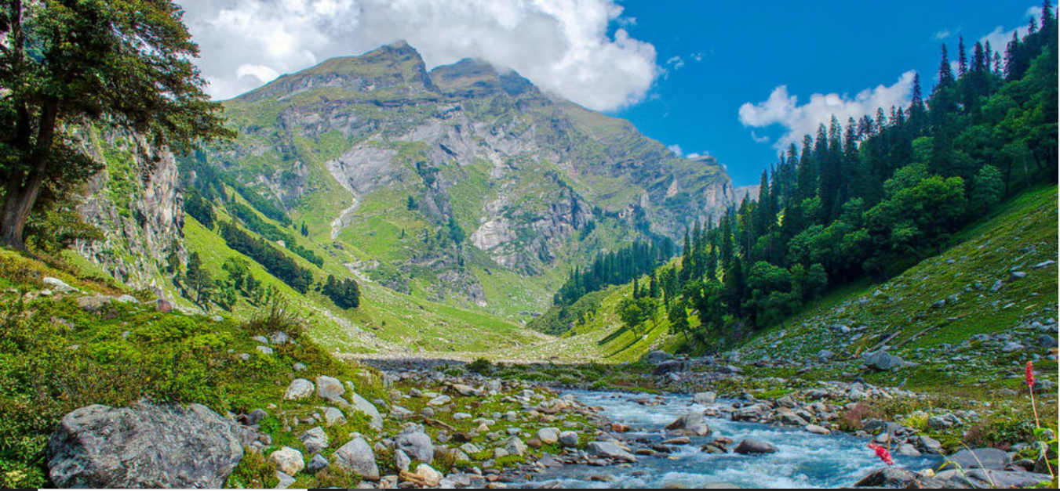

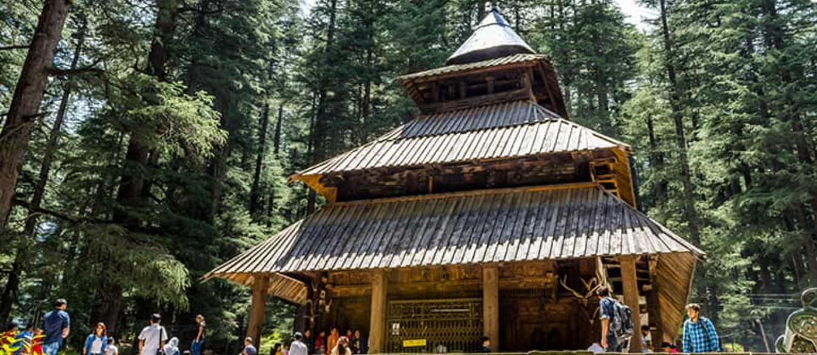

Few of the sample images about the locations. The images are Solang valley, Beas kund river and Hadimba temple respectively.

1. Ways to reach Manali – This section has information of ways to reach manali, i.e. via air, road and rail.

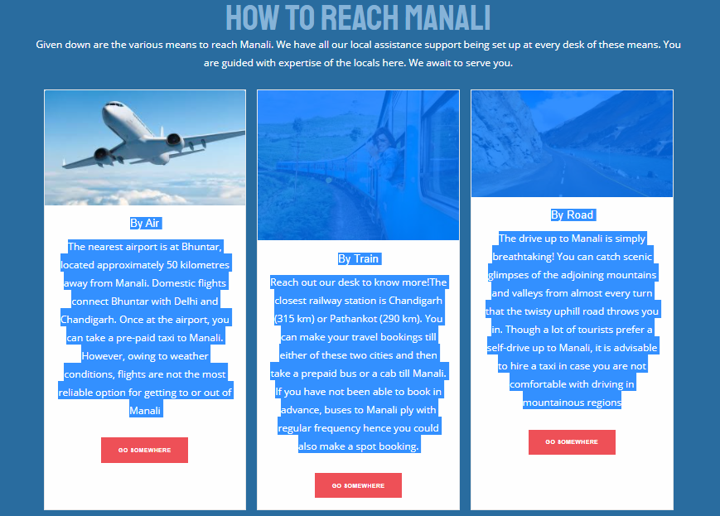

1. Testimonials – People rely on feedback and testimonials, so here are a few testimonials given by our customers.

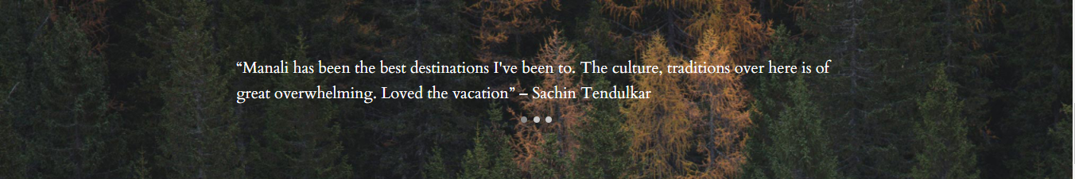

1. Lodging – Every tourist place need to have space to adjust to allocate the passengers. Hence here we have given the form for the user to select the required thing based upon his needs. The form contains part of manali, check-in and out date, number of adults children and the rooms.

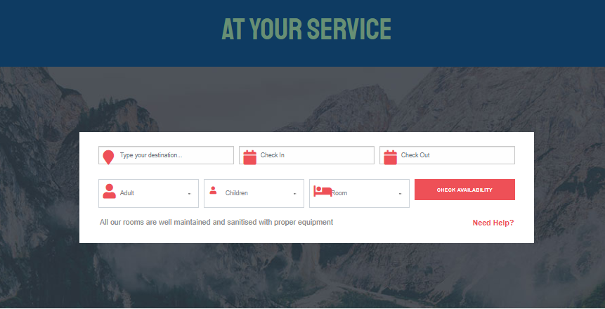

1. Food – Food is major part of any tourist place. Hence providing all the traditional and local dishes of Manali. This section has been implemented using bootstrap and on hover on the card, it gets flipped providing much information about the food. The information needs to be added.

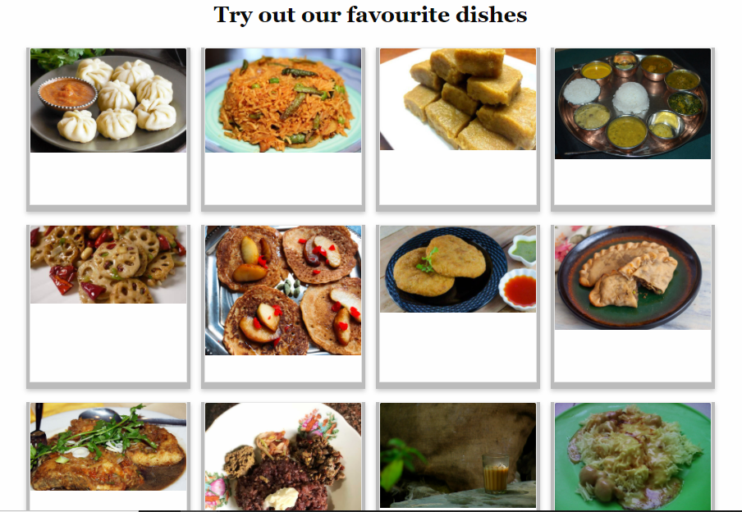

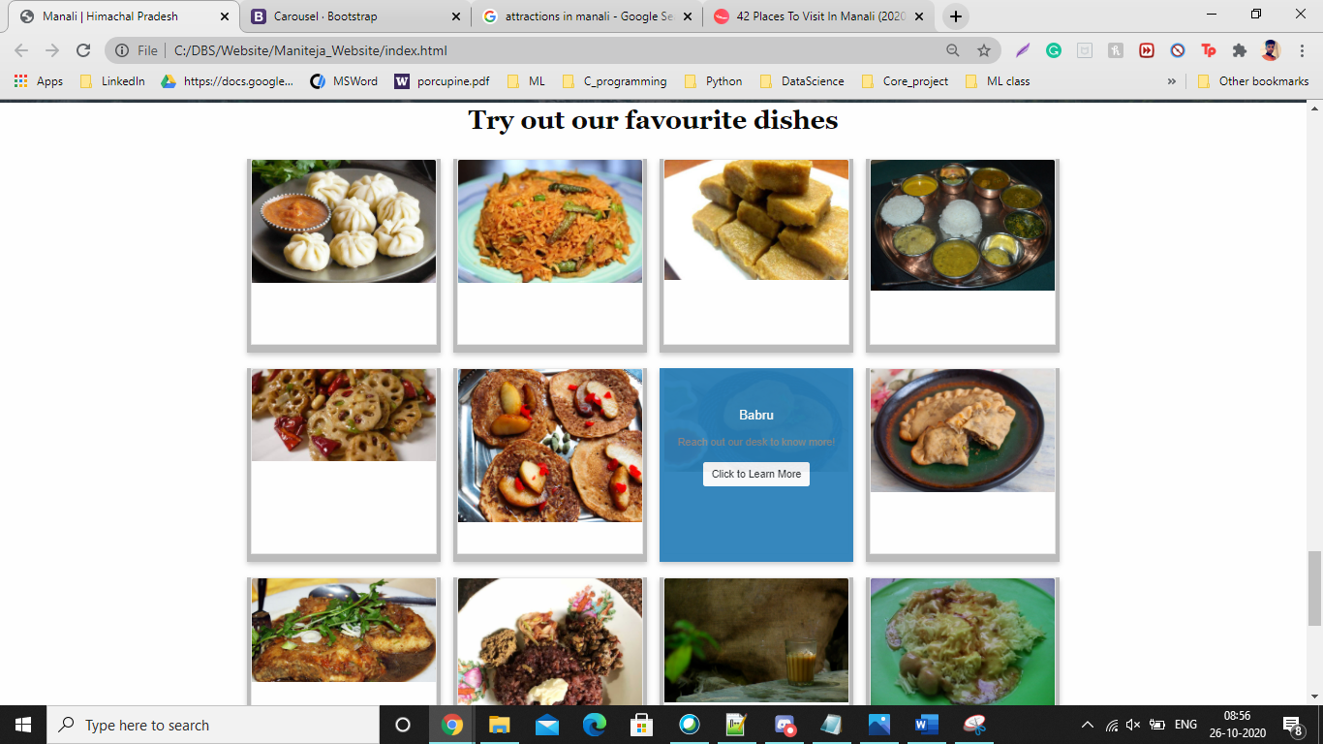

1. Feedback – Customer has the facility to provided feedback or has the rights to know much information from us. Hence providing them with the form.

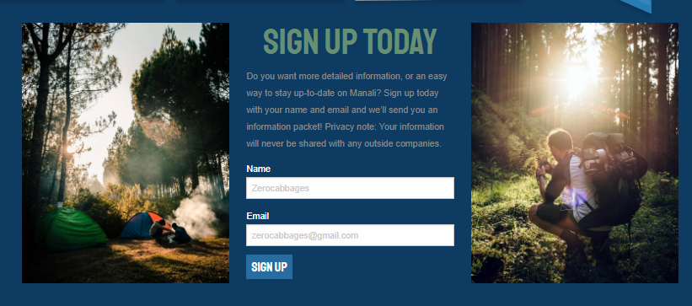

1. Footer – the footer contains the marquee for the copyrights and the button which when clicked routes back to the start of the page.



Thank You